OBSERVATIONAL QUESTIONS
Small Telescope
In this round you are going to observe the Moon using the telescope you have already made. Set up your telescope in the table provided for you. You have get a map of the Moon and an answer sheet. Please write or draw the answer of these questions in the answer sheet.
- Point your telescope to the Moon, sketch termination line of the Moon on the chart given. (25 points)
- Write down the cardinal directions in the chart (N,S,E,W) (25 points)
- Mark the position of the south pole of the Moon. (25 points)
- Mark the position of the famous Tycho crater. (25 points)

Map of the Moon

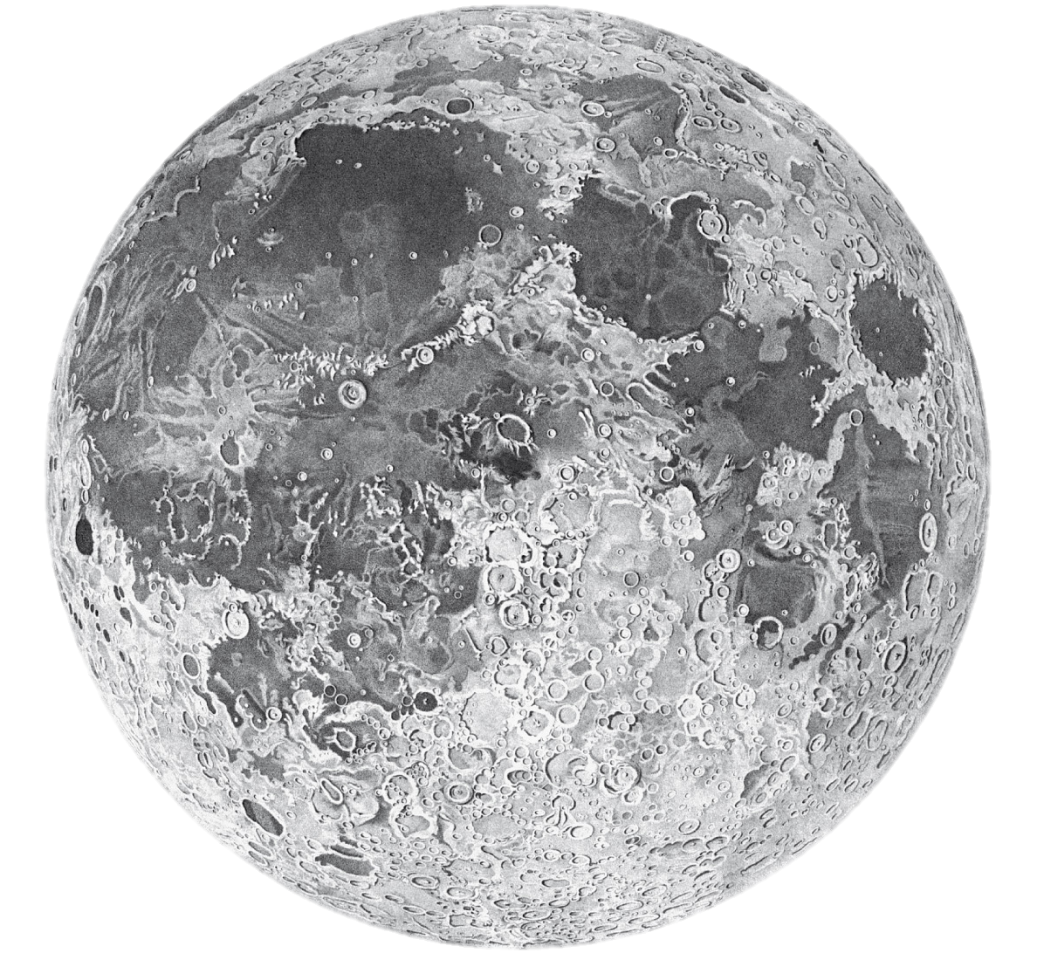

SMALL TELESCOPE OBSERVATION ANSWER SHEET

